Hudson Primary Academy
Hey Dads,
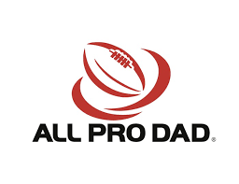
All Pro Dad
Dad’s Breakfast

Team up with other dads and kids for a quick before-school breakfast, and a short program of fatherhood and family topics. You’ll take away some great tips and resources to help you be the best dad you can be, and you’ll strengthen your relationship with your kids at the same time.
It’s fun, and it’s FREE! See you there……
Friday March 11th at 9:00 AM
All fathers, father figures and male role models are invited

Future 2022 Dates: April 8
- - - - - - - - - - - - - - - - - - - - - - - - - - - - - - - - - - - - - - - - - - - - - - - - - -
All Pro Dad RSVP for Friday March 11th
Name ______________________ Child’s Name ______________________

Hudson Primary Academy
Hey Dads,
All Pro Dad
Dad’s Breakfast

Team up with other dads and kids for a quick before-school breakfast, and a short program of fatherhood and family topics. You’ll take away some great tips and resources to help you be the best dad you can be, and you’ll strengthen your relationship with your kids at the same time.
It’s fun, and it’s FREE! See you there……
Friday March 11th at 9:00 AM
All fathers, father figures and male role models are invited

Future 2022 Dates: April 8
- - - - - - - - - - - - - - - - - - - - - - - - - - - - - - - - - - - - - - - - - - - - - - - - - -
All Pro Dad RSVP for Friday March 11th
Name ______________________ Child’s Name ______________________

