2020-21 Data Review Narrative School: Hudson Primary Academy formerly Northwest Elem.
School Executive Summary
Description of the school: Hudson Primary Academy is located in Hudson, Florida. It opened its doors during the 1974-1975 school year. In the 2020-2021 school year, the school received a full remodel and is now deemed a state of the art facility.

In the 2021-2022 school year, Husdon Primary Academy will house students in PreKindergarten through 3rd grade. The school’s K-3rd enrollment will be approximately 470. Additionally, HPA is home to 6 InD K-5th classrooms, and up to 8 preK units.

Execeptional Student Education Services: We will have 9 self-contained ESE classrooms. Here is a breakdown of the classrom settings and description of the programs:
- 2 PreKindergarten classrooms of Varying Exceptionalities (PreK VE). The PreK program addresses the needs of students with moderate developmental delays in multiple areas via part-time or full-time basis.
- 1 classroom of Developmental PreKindergarten. This program addresses students with significant cognitive, communication, and independent functioning needs. DPK programs also provide skilled medical supports if needed.
- 2 Skilled Medical Supports are offered to students requiring such services (e.g. tube feeding, suctioning, etc.) either in the ESE classroom or in the general education setting. Students in these classrooms participate in the Access Curriculum Program: Participatory (ACP-P). It offers a curriculum based on the access points for students with a significant cognitive disability at the participatory level and supports for students with mild/moderate behavioral needs.
- 2 Access Curriculum Supported Program: (ACP-S) offers a curriculum based on the access points for students with a significant cognitive disability at the supported level and supports for students with mild/moderate behavioral needs.
- 2 Access Curriculum Independent Program: (ACP-I) offers curriculum based on the access points and supports for students with a significant cognitive disability at the independent level and supports for students with mild/moderate behavioral needs.

Hudson Primary Academy is a Title I school, with approximately 84% of students receiving free or reduced lunch. Faculty members are highly qualified and certified in field. We currently employ 132 staff members including three administrators, 5 content area coaches, 2 behavior specialists, 2 counselors, a graduation enhancement teacher, and mulitple instructional and noninstructional positions.

Current Demographics
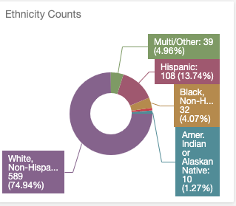
School’s purpose/mission: The mission of Hudson Primary Academy will create lifelong learners with positivity, security and support. To accomplish this mission, Hudson Primary Academy focuses on three areas that align with the district goals of Data Driven Decisions, High Impact Instruction and Collaborative Culture. The goals for Husdon Primary Academy are:

Data Driven Decisions: Progress monitoring
HPA will utilize systems to collect and organize data in order to monitor proficiency and growth for all students. As a school, HPA will engage in the problem-solving process using data to monitor the effectiveness of core instruction and intervention supports. HPA will use progress montioring data to reflectively improve and plan for implementation of differentiated practices within tier I instruction.
- Utilize essential standards to determine area of focus for tier II and III
- Correlate tier instruction resources for essential standard identified
- Increase monitoring of data analysis protocols
- Use data to progress monitor subgroup performance to ensure students are making progress towards meeting standards at an equitable level
- Utilize school based resources to support tier needs in behavior and attendance
- Reflect and respond to tier 1 instructional needs based on CFA and formal assessment data

High Impact Istruction:
Teachers will deliver lessons that are aligned to the rigor of the standards, instructional shifts, and Cambridge teacher attributes. Teacher teams will intentionally plan to build independence and stamina through questions, engagement strategies, and opportunities for student collaboration.
- Intentional planning to incorporate BEST standards, Cambridge teacher attributes, and engagement strategies attending to instructional shifts and Early Literacy emphesis
- Questions will intentionally target the standard and allow opportunities for student discourse to deepen understanding and allow for multiple perspectives and solutions
- Student Engagement strategies will allow for student perseverence and collaboration when solving complex problems or questions as designed and montiored through teacher team collaboration
- Release reading and practice to students throughout lesson to encourage independence and provide differentiated supports to ensure student success
- Plan for reflective teaching and learning practices to emphesize the process as well as the product

Collaborative Culture:
In order to increase staff and student engagement, HPA will establish and montior a culture of collaboration and communication through PLCs and MTSS infrastructures. School teams will meet to monitor the goals and needs of the school.
- Revist and revise school mission and purpose statements to reflect Early Literacy, Cambridge, and school restructuring utilizing stakeholder feedback and participation
- Participate in Global Perspectives school-wide
- Continue to gather and implement feedback to improve climate and culture at HPA
- Continue SIT/MTSS structures to support teachers and students (academic, behavior, SEL, and attendance)
- Opportunities for all stakeholders to provide feedback, collaborate, and problem solve
- Team building opportunities planned to foster positive school climate and culture including summer retreat
- Continue SEL training for staff and students
- Vertical planning opportinuties for grade level teams

In order to provide a world class education, we purchase additional support staff to model lessons, co-teach lessons and work side-by-side with teachers to enhance their craft as well as provide behavior techniques and classroom management strategies. The support staff includes a Learning Design Coach, Instructional Trainer Coach for Literacy, Instructional Trainer Coach for Mathematics, Cambridge Coach, Graduation Enhancement Teacher, Behavior Specialist, and Reading Interventionists for primary and intermediate students.

We value student leadership and take pride in the opportunities we provide for our students through the following programs: Safety Patrol, Recycling, Wellness Garden, Student Council, and Community outreach.

Notable achievements and challenges:
Hudson Primary Academy has a Positive Behavior Support Program that focuses on providing a safe and positive learning environment. The school-wide system of support includes proactive strategies for defining, teaching, and supporting appropriate student behaviors to create a positive school environment. We have a group of stakeholders that meet on a monthly basis to discuss minor incident data, attendance data, referral data, and how our systems are working. This goup reviews our practices and determines if changes need to be made. We are proud of the work we have accomplished over the years to improve our system and was recognized as a Gold Model PBIS school.

In July of 2020, we offficially became a part of the Cambridge International community. We are excited to offer our students real world experiences that will lead to deeper learning. The students are emersed in the 5 Cambridge Learner Attributes of confident, responsible, reflective, innovatove and engaged which are critical skills needed to be successful in college, career and life. Our students are also engaged in Global Perspective activities 1 time per month. Through Global Perspectives, our students are developing skills of research, analysis, evaluation, reflection, colloboration and communication. Students are also making connections across subject areas.

Additional information: Any trainings our staff will be involved in such as: SEL, B.E.S.T Standards trainings, Cambridge PD, Reading Endorsement coursework, Workshop Wednesday content, Moved to a temporary location, Monthly Data Chats to review progress of students, IRLA data wall, tier II/III, SIT weekly meetings, NWEA data, Mentorship for new teachers
Student Data (Please refer to links below to assist)
Overall Data Strengths Summary: Increase of Gallup score during Pandemic/ School Closure/ School Renovation Move/ School Restructure/ MSOL/Blended/Brick and Mortar, systematic Tier 2 and Tier 3 intervention and monitoring system, increased student IRLA proficiency, implemented Cambridge and Global Perspectives, implementation of NWEA/Maps problem solving, implementation of Tier 2/ Tier 3 Math structures, additional collaboration for student supports with STAR and ESD.

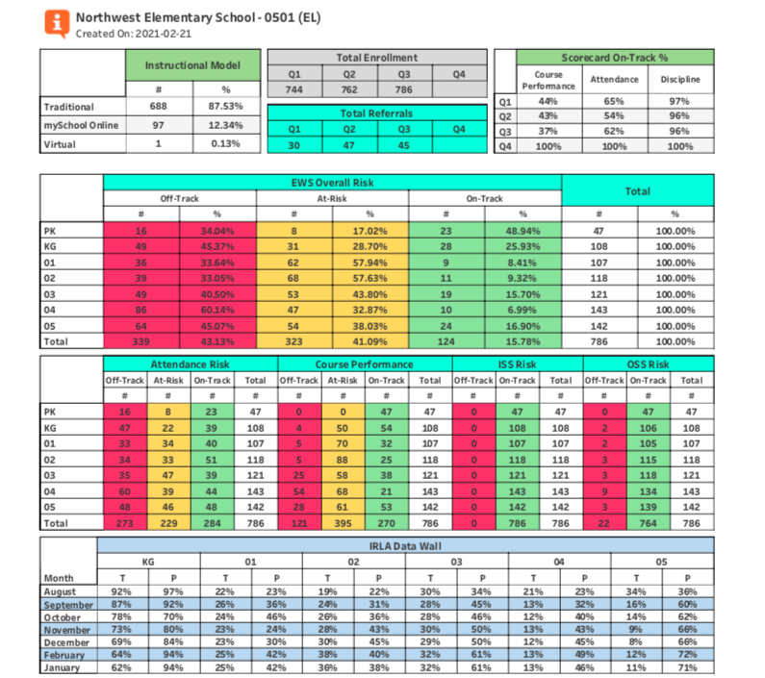
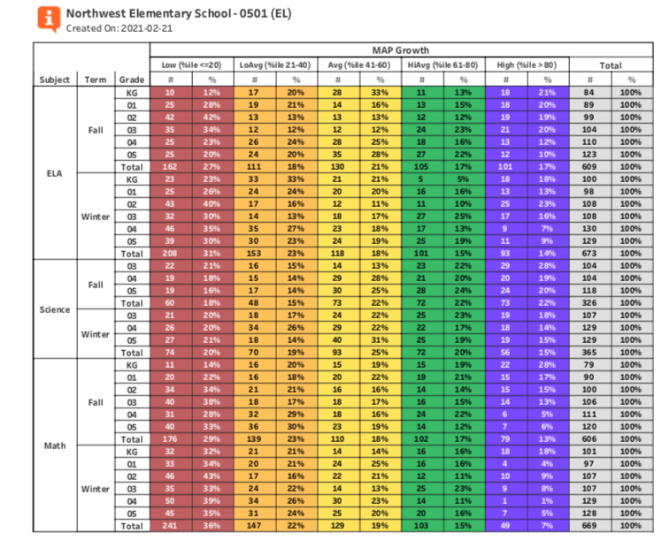

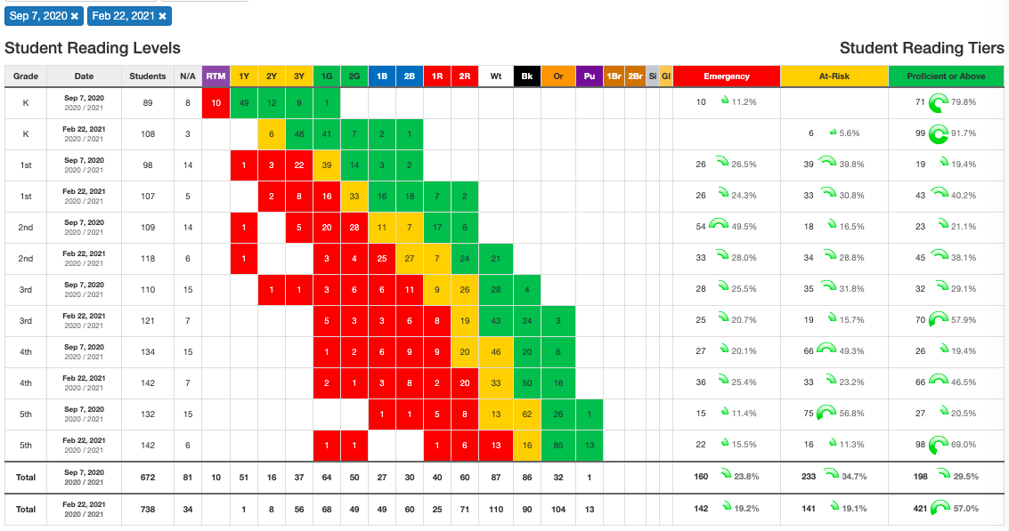
Overall Data Areas of Growth Summary: Increase students on target in IRLA, increase student proficiency in ELA, Math and Science; performance of students in the Lowest Quartile; subgroup discrepancies (gaps).

- Positive or negative student performance trends over three years: Data trends for the past 3 years are indicating student foundational gaps increased and more students need tier supports to supplement tier 1 instruction. Specific assessment data is indicated below.

- For CNA, Part 2, HS Only:
  - What populations are underrepresented (percentage of the population in a group is lower than the percentage of the total population) in your CTE programs? Enter underrepresented populations here.
  - What efforts have been made to recruit underrepresented student populations for your CTE programs? Describe efforts here.

- Summarize the achievement and EWS/myGradSuccess levels of students in the following subgroups.
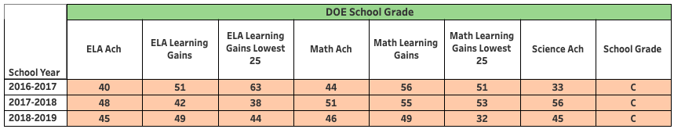
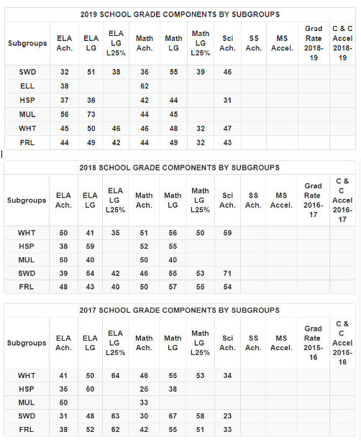

Winter NWEA by Subgroups
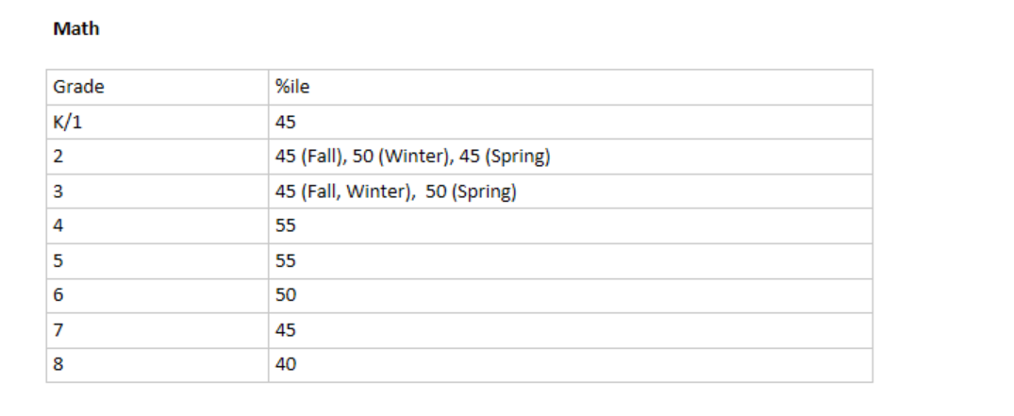
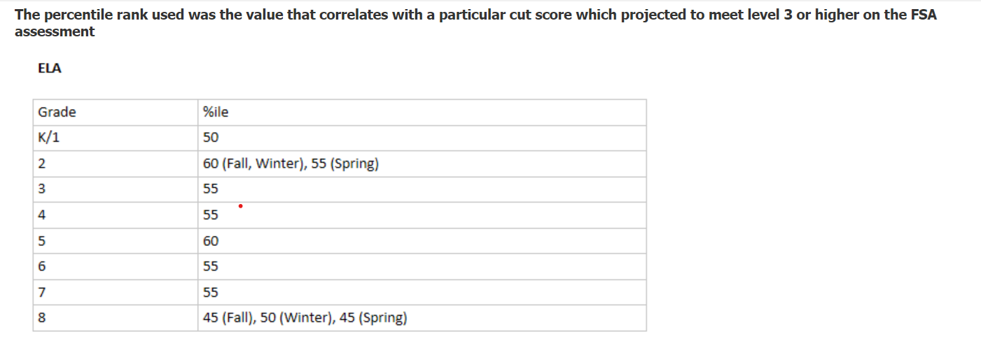

% proficient | 3rd ELA 55%ile | 4th ELA 55%ile | 5th ELA 60%ile
Overall | 49/111= 44% | 31/132= 24% | 35/131= 27%
SWD (no speech) | 2/14= 14% | 3/22= 14% | 4/23= 17%
FDL/ED | 35/ 91= 38% | 24/ 112= 21% | 25/104= 24%
Black | 2/5= 40% | 2/5= 40% | 2/7= 29%
Hispanic | 4/11= 36% | 2/23= 1% | 3/18= 17%
ELL/LEP | 1/3= 33% | 1/13= 1% | ¾= 75%
Lowest %ile | NA | 0/ 21= 0% | 0/21= 0%
Homeless | 0/6= 0% | 0/4= 0% | 0/5= 0%
MSOL current roster 2/24/2021 | 7/16= 44% | 4/20= 20% | 13/37= 35%

% proficient | 3rd Math 45%ile | 4th Math 55%ile | 5th Math 55%ile
Overall | 47/111=42% | 22/132= 17% | 35/131= 27%
SWD (no speech) | 1/14= 1% | 1/22= 1% | 2/23= 1%
FDL/ED | 35/91=38% | 15/112= 13% | 26/104= 25%
Black | 2/5=40% | 2/5= 40% | 3/7= 43%
Hispanic | 3/11=27% | 2/23= 1% | 4/18= 22%
ELL/LEP | 1/3=33% | 1/ 13= 1% | ¼= 25%
Lowest %ile | N/A | 0/15= 0% | 0/28= 0%
Homeless | 0/6=0% | 0/4= 0% | 0/5=0%
MSOL current roster 2/24/2021 | 5/16=31% | 3/20= 15% | 11/37= 30%

% proficient | 3rd Science 50%ile | 4th Science 50%ile | 5th Science 74%ile
Overall | 61/110= 55% | 49/131= 37% | 33/131= 25%
SWD | 4/13= 31% | 5/22= 23% | 4/23= 17%
FDL/ED | 46/90= 51% | 39/111= 35% | 26/104= 25%
Black | 4/5= 80% | 1/5= 20% | 1/7= 14%
Hispanic | 3/10= 30% | 7/22= 32% | 3/18= 17%
ELL/LEP | 1/3= 33% | 2/13= 15% | 0/4= 0%
Homeless | 2/6= 33% | 1/3= 33% | 0/5=0%
MSOL current roster 2/24/2021 | 10/16= 63% | 5/20= 25% | 6/35= 17%

SWDs:
(Grade 3-14 students; Grade 4- 22 students, Grade 5-23 students) (Not including Speech)
According to Winter NWEA/ MAPs data, SWD demonstrate a gap in the areas of Third and Fifth ELA; Third, Fourth, and Fifth Math; and Third and Fourth Science.

FRL/ED:
(Grade 3-91 students; Grade 4- 112 students, Grade 5-104 students)
There is no gap demonstrated by Winter NWEA/MAPs data. FSA data from 2019 does not indicate significant gaps between FRL/ED and overall achievement categories.

Black:
(Grade 3-5 students; Grade 4- 5 students, Grade 5-7 students)
According to Winter NWEA/MAPs data, there is a gap in Fourth and Fifth Grade Science.

Hispanic:
(Grade 3-11 students; Grade 4- 23 students, Grade 5-18 students)
According to Winter NWEA/MAPs data, there is a gap in Fourth and Fifth Grade ELA; Third and Fourth Math; and Third Science. FSA data from 2019 does not indicate significant gaps between Hispanic and overall achievement categories.

ELL/LEP:
(Grade 3-3 students; Grade 4- 13 students, Grade 5-4 students)
According to Winter NWEA/MAPs data, there is a gap in Third and Fourth Grade ELA; Fourth Grade Math; and Third, Fourth, and Fifth Grade Science. In 2019 overall math FSA achievement was at 45%. ELL math achievement was at 62%

Lowest %tile:
(Grade 3- NA; Grade 4 ELA- 21 students, Grade 4 Math- 15 students Grade 5 ELA-21 students, Grade 5 Math-28 students)
According to Winter NWEA/MAPs data, there is a gap in Fourth and Fifth ELA; and Fourth and Fifth Math.

Homeless:
(Grade 3-6 students; Grade 4- 4 students, Grade 5-5 students)
According to Winter NWEA/MAPs data, there is a gap in Third, Fourth and Fifth ELA; Third, Fourth and Fifth Math; and Third and Fifth Science.

Migrant:
Currently 0%

MSOL:
(Grade 3-16 students; Grade 4- 20 students, Grade 5-37 students)
According to Winter NWEA/MAPs data, there are no gaps in ELA; there is a gap in Third Grade Math; and Fourth Grade Science.

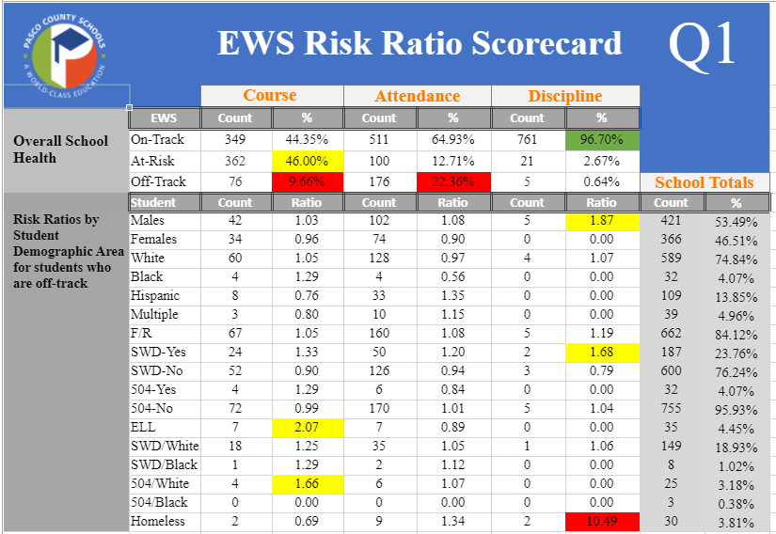
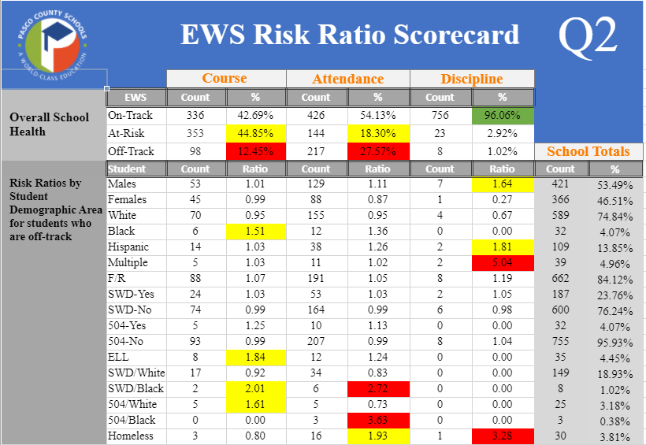
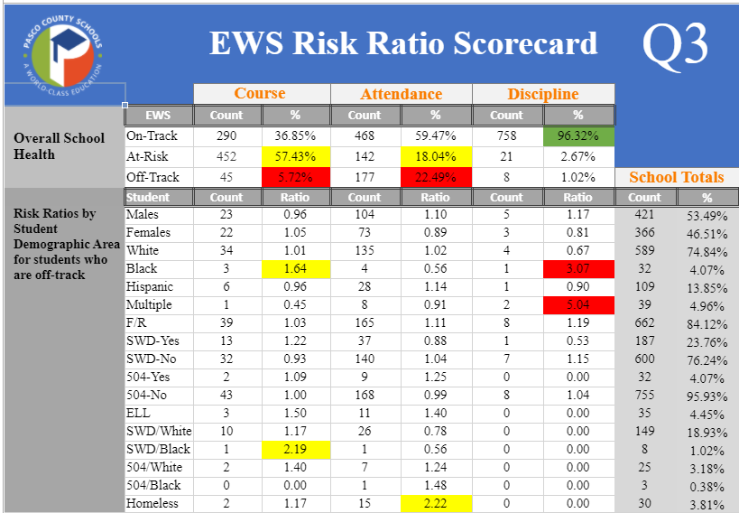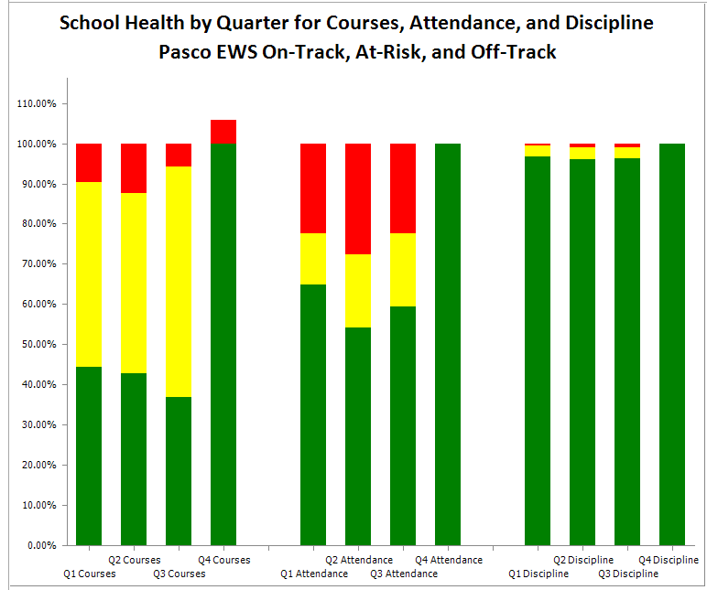

Data Sources/Links:
FSA by Subgroup Historical (2017, 2018, 2019)
School Data Sheet
Quarterly Check Data by Subgroup (US History, Biology, Civics)
Lowest 35, Migrant, and Homeless Data (In Student Data Sheets, go to List view and filter)
EWS Scorecard
myGradSuccess (High School Only)
For CNA Part 2: CTE targeted sub-populations (High School Only)

Staff and Student Engagement Data (Gallup and other engagement data)
- Briefly discuss staff engagement strengths and areas for growth
Areas of strength are:
- We increased our overall engagement from 31% to 57% which is a + 26.
- Increased our overall engagement from 3.81 to 4.17.
- Q00: How satisfied are you with your organization as a place to work increased from 3.71 to 4.05.
- Q01: I know what is expected what is expected of me at work increased from 3.71 to 4.55.
- Q03: At work, I have the opportunity to what I do best every day increased from 3.80 to 4.12.
- Q04: In the last 7 days, I have received recognition or praise for doing good work increased from 3.03 to 4.04.
- Q05: My supervisor or someone at work, seems to care about me as a person increased from 3.96 to 4.22.
- Q06: There is someone at work who encourages my development increased from 3.70 to 4.24.
- Q07: At work, my opinion seems to count increased from 3.03 to 3.88.
- Q08: The mission or purpose of my organization makes me feel my job is important increased from 3.80 to 4.23.
- Q09: My associates are committed to doing quality work increased from 4.28 to 4.46.
- Q11: In the last six months, someone at work has talked to me about my progress increased from 3.58 to 4.11.
- Q12: This last year I have opportunities to work to learn and grow increased from 4.10 to 4.33.
Areas for growth are”
- Q02: I have the materials and equipment I need to do my work right decreased from 4.06 to 3.99.
- Q10: I have a best friend at work decreased from 3.97 to 3.84.
Response rate for Gallup: 77 staff members completed the Gallup Survey.

Positive or negative Gallup trends over three years: (See graphs below for trends). 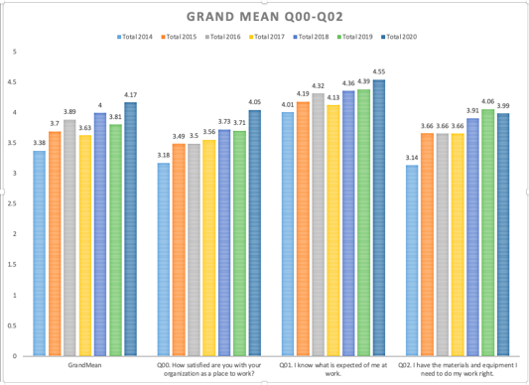
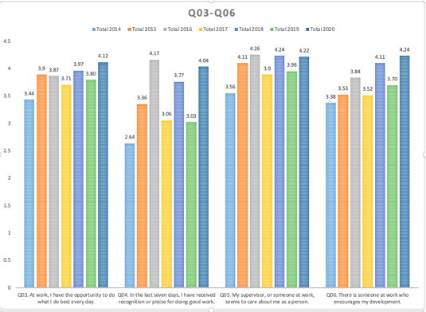
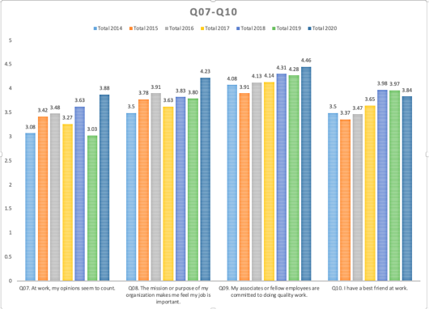
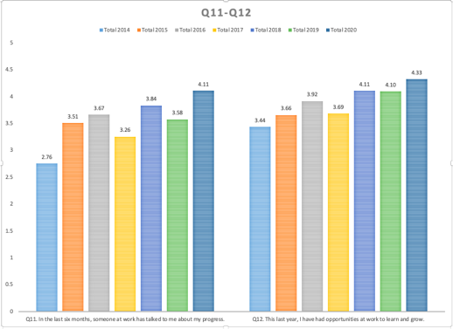
When reviewing Gallup Survey data over the past 7 years, the trend line is moving in a positive direction. The 2020 data is in dark blue.

- Briefly discuss student engagement strengths and areas for growth (Consider Gallup, EWS behavior and attendance, and Cognia tools)
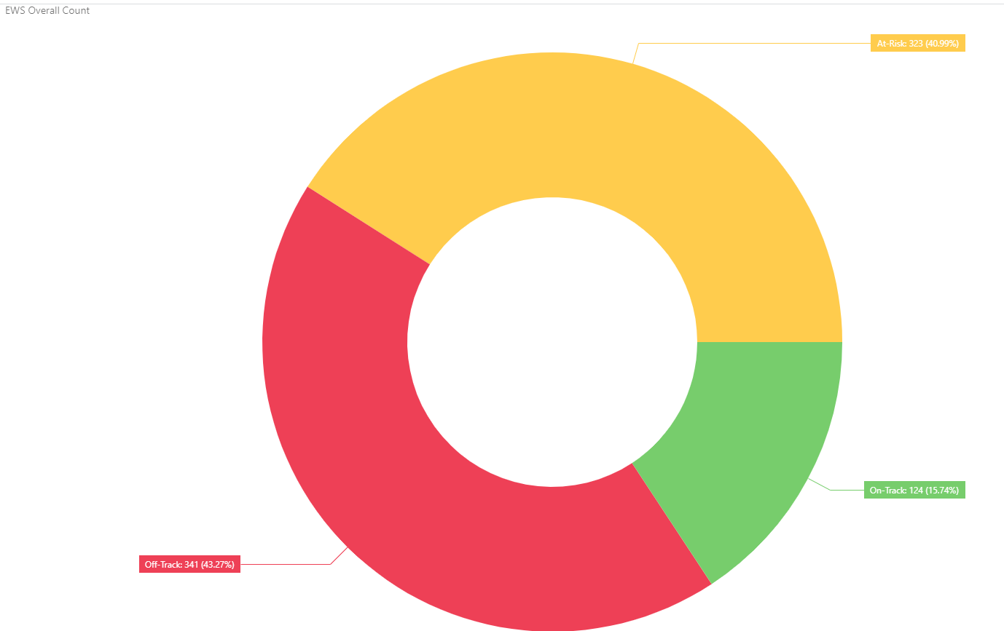
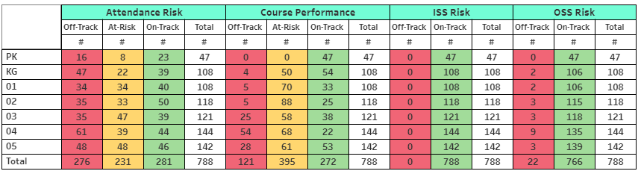
Response rate for Gallup Student Poll: 96 students participated in the Gallup Survey. The overall engagement score was 59% and the overall hope score was 40%

Areas of strength for Student Engagement:
- At this school, I get to do what I do best every day.
- In the last seven days, someone has told me I have done good work.
- The adults at my school care about me
- I have at least one teacher who makes me excited about the future.

Areas for improvement for Student Engagement:
- My teachers make me feel my schoolwork is important.
- I feel safe in this school.
- I have a best friend at school.
- In the last seven days, I have learned something interesting at school.

Areas of strength for Student Hope:
- I have a great future ahead of me.
- I can find many ways around problems

Areas for improvement for Student Hope:
- I know I will graduate from high school.
- I can think of many ways to get good grades.
- I have many goals.
- I know I will find a good job in the future.

Enter areas of growth here
Positive or negative trends over three years: Our Gallup is trending in a positive direction over the past 3 years.
Parent Engagement Data (Parent Survey)
Title I Schools must also collect parent and community feedback on the CNA, Parent and Family Engagement Plan, the Home School Compact, how to spend Title I funds on Parent Engagement, barriers to parent engagement and how parents can assist in the learning process. The document and supporting details regarding all the required areas can be found in SharePoint and Title I Crate. Documentation that input has been gathered in all the required areas is due in Title I Crate by April 14.

Response rate for Cognia Parent Survey: 21 respondents
Briefly discuss parent engagement strengths and areas for growth
Areas of strength are: Overall score of 3.99, Highest performing items: 4.40 My child knows the expectation for learning in all classes. 4.35 My child has up to date computers and other technology to learn. 4.30 All of my child’s teachers give work that challenges my child. 4.30 The teacher uses a variety of teaching strategies and learning activities. 4.25 All of my child’s teachers work as a team to help my child learn. 4.25 My child sees a relationship between what is being taught to his or her everyday life. 4.25 The school provides an adequate supply of learning resources that are current and in good condition.

Areas for growth are: 3.70 My child has administrators and teachers that monitor and inform me of his or her learning progress. 3.70 All of my child’s teachers keep me informed regularly of how m y child is being graded. 3.55 Our school provides opportunities for stakeholders to be involved in the school. 3.50 Our school communicates effectively about the school’s goals and activities. 3.50 Our school’s purpose statement is formerly reviewed and revised with involvement from parents. 3.20 Our school provides opportunities for students to participate in activities that interest them.
Trends over time from various tools used to gather input from parents: Parent surveys over time indicate parents are satisfied with the educational experience at NWES and feel strongly that teachers and staff care about their child. Parents indicate interest in participating in before and after school learning opportunities for their children and parent activities. Parent preferences indicate more interest in family activites verses parent information activites. Declines in survey satisfaction with parent involvement and parent communication are noticable this year. This is believed to be in response to guidelines restricting parent and volunteer activitities on campus due to Covid. Parents look forward to tradiditonal activities such as Holiday night and Spring Carnival and are disappointed not to have these held this year. Parents are typically invited to attend in person PMP conferences and parent teacher conferences, however, due to restrictions, these have been held virtual this year.

Implementation Data
Observation Data: Enter strengths of note and challenges regarding instruction and engagement in the classroom

Artifacts/Products from the District Key Priorities Guide
Check any that are developed at your building:
×RtI at Work Pyramid
×Gallup survey action plan
×List of students needing support at each tier (academic and behavior)
×Action plans to provide support at each tier (academic and behavior)
×Essential standards/learning charts
PLC Team response to common formative assessments (CFAs)
MyGrad Success Action Plan (HS only)
Student Leadership Group and Goal Setting Plans

- Artifacts/products that are a strength (Only 1 or 2)
- Gallup Survey Action Plan with recorded feedback from staff and documented responses to support requested improvements.
- Gallup Survey Committee meets every quarter.
- Data Wall 3.0 documented tier I, tier II, tier III level students for grades K-5 including tier intervention plans and structures.
- Tier II and Tier III progress monitoring logs in SharePoint to track student growth.
- IRLA growth monitoring and action planning
- Data wall 3.0 with documented attendance, behavior and social emotional groups
- Data wall 3.0 with documented information for our PreK and InD students
- Grade level data boards
- Monitoring of lowest 35% students
- PLC action plans, agenda, and minutes are recorded in SharePoint
- PBIS system, incentives, school-wide expectations
- PBIS random rewards
- Gold Model School
- Master schedule includes Tier II/III
- PLC schedule for teams
- Instructional Assistants support student groups throughout the day
- Social Emotional Learning on Early Release Days
- Workshop Wednesdays to provide growth opportunities.
- SIT grade level support point person and weekly grade level team meetings.
- Global Perspective Days
- Staff and students emersed in the 5 Cambridge Attributes
- Artifacts/products that are areas for growth (Only 1 or 2)
- Staff attendance
- Student attendance
- B.E.S.T. Standards
- Become familiar wth the Cambridge crosswalk

Focus Areas for Next Year
In this section, consider strengths and challenges from all your data sources. You must include strategies and/or PD that elevate collaborative, equitable instructional, inclusive, and high leverage practices for all populations of students.

- What are your draft goals for the 2021-22 school year based upon the data you describe?

Data Driven Decisions: Progress monitoring
HPA will utilize systems to collect and organize data in order to monitor proficiency and growth for all students. As a school, HPA will engage in the problem-solving process using data to monitor the effectiveness of core instruction and intervention supports. HPA will use progress montioring data to reflectively improve and plan for implementation of differentiated practices within tier I instruction.
- Utilize essential standards to determine area of focus for tier II and III
- Correlate tier instruction resources for essential standard identified
- Increase monitoring of data analysis protocols
- Use data to progress monitor subgroup performance to ensure students are making progress towards meeting standards at an equitable level
- Utilize school based resources to support tier needs in behavior and attendance
- Reflect and respond to tier 1 instructional needs based on CFA and formal assessment data

High Impact Istruction:
Teachers will deliver lessons that are aligned to the rigor of the standards, instructional shifts, and Cambridge teacher attributes. Teacher teams will intentionally plan to build independence and stamina through questions, engagement strategies, and opportunities for student collaboration.
- Intentional planning to incorporate BEST standards, Cambridge teacher attributes, and engagement strategies attending to instructional shifts and Early Literacy emphesis
- Questions will intentionally target the standard and allow opportunities for student discourse to deepen understanding and allow for multiple perspectives and solutions
- Student Engagement strategies will allow for student perseverence and collaboration when solving complex problems or questions as designed and montiored through teacher team collaboration
- Release reading and practice to students throughout lesson to encourage independence and provide differentiated supports to ensure student success
- Plan for reflective teaching and learning practices to emphesize the process as well as the product

Collaborative Culture:
In order to increase staff and student engagement, HPA will establish and montior a culture of collaboration and communication through PLCs and MTSS infrastructures. School teams will meet to monitor the goals and needs of the school.
- Revist and revise school mission and purpose statements to reflect Early Literacy, Cambridge, and school restructuring utilizing stakeholder feedback and participation
- Participate in Global Perspectives school-wide
- Continue to gather and implement feedback to improve climate and culture at HPA
- Continue SIT/MTSS structures to support teachers and students (academic, behavior, SEL, and attendance)
- Opportunities for all stakeholders to provide feedback, collaborate, and problem solve
- Team building opportunities planned to foster positive school climate and culture including summer retreat
- Continue SEL training for staff and students
- Vertical planning opportinuties for grade level teams

- For each goal, what strategies and PD will you coordinate and/or facilitate to these goals?
  - Mission and purpose statement revision and development
  - BEST standards training
  - Early Literacy Committee
  - Workshop Wednesday structures
  - Cambridge/Global Perspectives trainings
  - PLC structures/Supported Planning
  - MTSS/SIT structures to support student
  - SEL training
  - Master schedule creation to support MTSS
  - CFA development and action planning
  - Differentiation training
  - Reading series adoption training
  - NWEA reporting to include subgroup monitoring
  - DBQ supports in grade levels and incorporation of related reading strategies

- How will your school coach/coaches facilitate your draft goals? (see responses below)

Learning Design Coach
My role as a Learning Design Coach at Hudson Primary Academy will align with District and School Wide goals to support Data Driven Decisions, High Impact Instruction, and Collaborative Culture.

Data Driven Decisions
- Create, model, and support data sheets for Tier Instruction for all grade levels
- Will use multiple data sources to support Coaching Cycles with teachers
- Based on school initiatives, data, and collaboration with stakeholders, provide guidance in operational procedures for media/collaboration centers and computer labs; purchasing of resources in regards to media and technology
- Will use data from NWEA and Affirm to support teachers in all Math Tiers of instruction
- Participate in walk-throughs and use the data in order to create coaching plans for staff
- Create and collect data for monthly writing assessments and train staff how to plan from the data
High Impact Instruction
- Offer weekly Professional Development on Instructional Strategies, Instructional Shifts, Engagement Strategies, BEST Standards, and Technology Support
- Utilize school PLCs to support teachers with planning for high impact learning experiences that are standards based and integrate instructional shifts
- Will continue to offer Professional Development, model, and support for Document Based Questions (DBQs)
- Support teachers by modeling, co-teaching, and planning based on the BEST standards in their instruction
- Model and support 21st century skills in the classroom to promote an engaging lesson for all students
- Develop the use of innovative technologies that impact teaching and learning to include showcasing of innovative instructional design resources to school through PLCs, one-to-one coaching and staff professional development

Collaborative Culture
- Collaborate to support online environments, including MySOL classes, NWEA testing, and FLVS Module supports
- Test Administrator for State Testing (FSA, FCAT Science, WIDA)
- Support Global Perspectives by creating the Canvas courses and working with the Cambridge Coordinator
- Will facilitate Professional Learning Communities (PLCs)
- Attend District trainings and bring back and train the staff on District initiatives
- Support Parents, Teachers, and Students by offering Tech Support/Troubleshooting
- Run and maintain School Website
- Run and maintain Public and Staff Calendars
- Will be a mentor for new teachers

ELA-Literacy:
DDD:
During ELA PLCs the work will be on analyzing assessment data to make informed TIER 1, 2 and 3 decisions.

High Impact Instruction
Work with teachers on learning, understanding and implementing the B.E.S.T standards
Work with teachers on understanding the foundational skills for our primary students.
Model and co-teach lessons in grades K-3 with the new reading series
Model and co-teach DBQs in grades 2/3
Work with teachers on creating a literacy rich classroom along with engaging classroom libraries that go beyond just being organized by IRLA level.

Collaborative Culture:
Facilitate all ELA PLCs with our work centered around the B.E.S.T. standards, new reading series and foundational skills
Work with SIT teams to continue our work around MTSS structure that has been established.
Establish HPA Literacy Team

The literacy coach will collaborate with the leadership team to plan our work around the following:
Professional develeopment around the B.E.S.T. standards, new reading series foundational skills, literature rich classroom environment, and classroom libraries.
New reading series implementations
DBQs/Global Perspectives
Coaching Cyles using “The Impact Coaching Cycle”
Making decisions around assessment data
TIER 1, 2, and 3
Understanding the IPG tool
HPA Literacy Team

Cambridge Programme Coordinator:
DDD:
- Organize and participate in the recruitment of students

High Impact Instruction
- Design and structure Cambridge Global Perpesctives Challenges for each grade level
- Co-teach DBQ’s
- Promote strategies that enhance teaching and learning, focusing on the Cambridge Learner Attributes of Confident, Responisble, Reflective, Innovative, and Engaged
- Provide professional development opportunities for school personnel that encourages the Cambridge approach to teaching
- Work with District Science Curriculum Specialist and Stem Coach to link Cambridge science standards/activities to current classrom practices and student learning

Collaborative Culture:
- Utilize Professional Learning Community (PLC) structures to support teachers with planning and preparing for Global Perspectives
- Recognition of students and teachers who excel in the Cambridge Learner/Teacher attributes

STEM Science Coach:

Data Driven Decisions
- Will use science data from NWEA support teachers in 3rd grade
- Will use CFA data to help guide science instruction

High Impact Instruction
- Offer weekly Professional Development on instructional strategies, 5E lessons, effective questioning, and engagement strategies or active learners
- Plan with teachers using the 5E models provided by district
- Model and coach 5E science lessons
- Planning and modeling the use of technology for engagement especially through the use of Nearpod
- Incorporate high impact reading strategies into the science block
- Assist Cambridge Coordinator with implementation of the Cambridge Science standards through active learning instruction

Collaborative Culture
- Support Cambridge Science implementation
- Attend District and Cambridge trainings
- Meeting with teams regularly to support and plan science
- Establish a sense of importance and value of science lessons through vertical planning and coherence ladders (how each standard builds upon the pervious year) to create more successful science-minded individuals

Math Coach:
Data Driven Decisions

- Work with teams to utilize data gathered from Mid-Module, End-Module assessments, and NWEA results in order to plan for tier I nstruction.
- The essential standards for the grade band will be used to determine the area of focus for Tier II and Tier III instruction and will be monitored by the use of Tier logs.
- Data gathered from walkthroughs will be used to plan future coaching cycles with teachers.

High Impact Instruction

- Work with teams to intentionally plan opportunities for students to ask and answer questions based on the standard.
- Work with teams to intentinally plan opportunities for students to engage in mathematical discourse.
- Work with teams to plan engaging instruction in order to build students stamina.
- Work with teams to be able to negotiate when to release students to practice independently and when to pull back.
- Model, co-teach, and plan, content with teachers using Eureka and understanding how the standard is being taught.
- Engage in coaching cycles in order to enhance teacher practices.
- Provide professional development opportunities for teachers to furthur enhance teacher practices.
- Learn and understand, the B.E.S.T standards

Collaborative Culture

- Utilize PLC structures to support teachers with planning and preparing to teach the modules.

- What district supports will you need for your draft goals?
Support with new reading series, BEST standards, planning units, Early literacy structures, mission statement revision.

